**INTRODUCTION TO CORRELATION**

**A. Definition of correlation:** Used to ***understand the relationship*** between variables.

**B. Correlation coefficient:** Measures the strength of relationship between variables

1

-1

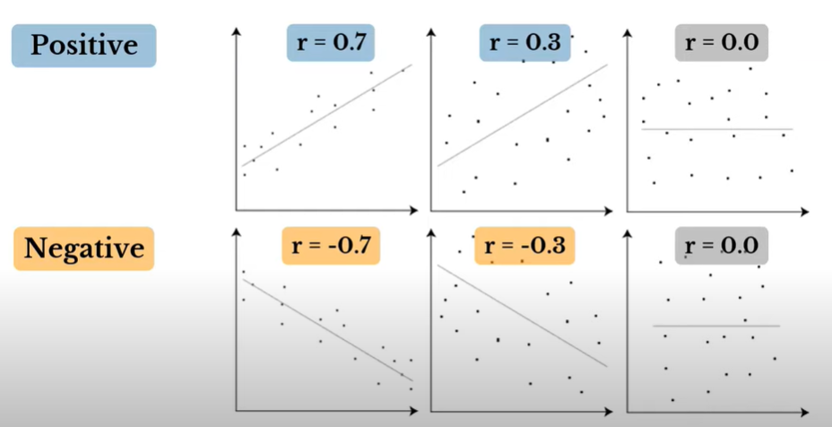  
  
  
  
  
  
For example, Is there a relationship between a person’s salary and age?

Strong  
Positive

No  
Correlation

Strong  
Negative

0

- In correlation analysis, we usually want to know 2 things:



Every single point is a person

+ How **STRONG** the **CORRELATION** is

+ and in **WHICH DIRECTION** the **CORRELATION** GOES

- We can read both in the **correlation coefficient** which is between **-1 and 1**

- The **strength of the correlation** can be read in a table.

NEGATIVE Correlation

When **high values** of **one variable**

POSITIVE Correlation

When **high values** of **one variable**  
  
  
  
  
  
  
  
  
  
- A **negative correlation** usually exists between **product prize** and **sales volume.**

Go along with ***LOW*** values of the other variable

Go along with **HIGH** values of the other variable

- The most popular are:

+ Person correlation coefficient r

+ Spearman correlation coefficient r3

+ Kendall’s tau

+ Point-Biserial correlation coefficient tpb